**Functional Document**

|  |  |
| --- | --- |
| **Application** | NGERP - Centra |
| **Service Bundle** | Sales Management |
| **Service Request** | Payment Netoff Authorization |

**Description :**

After saving payment netoff , Payment netoff can be completed in the payment netoff authorization screen. User can make payment by choosing the document type as netoff receipt in the payment screen.

**Workflow Process :**

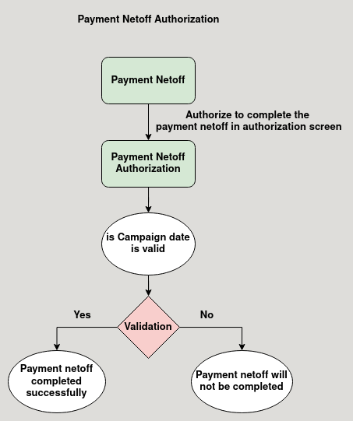

**Business Rules :**

* Payment netoff Authorization can be accessed only in HQ.
* After saving the payment netoff the document will be loaded in the payment netoff authorization screen.
* User Have to manually complete the payment netoff.
* payment netoff is matched with a payment in region by using the pair number.
* The document type for the payment netoff in payment screen is netoff receipt.
* After completing the payment the payment is loaded in payment allocation screen in region.